The Digestive System: Digestion and Absorption

1. List the three major nutrient classes (a.k.a. macronutrients).
______________
______________
______________
2. Which of the following carbohydrates is NOT a disaccharide?
maltose
lactose
starch
sucrose
3. Match the following pairs of molecules with their monomers by placing the number next to the matching letter:
Sucrose __________
Maltose __________
Starch ___________
Lactose __________
The monomers:
- Many glucose monomers
- glucose + fructose
- glucose + galactose
- glucose + glucose
4. The breakdown products (monomers) of proteins are __________ _________.
5. The breakdown products of triglycerides include monoglycerides and _______ _________.

6. Place the following labels on the diagram below:
- maltose
- maltotriose
- limit dextrin

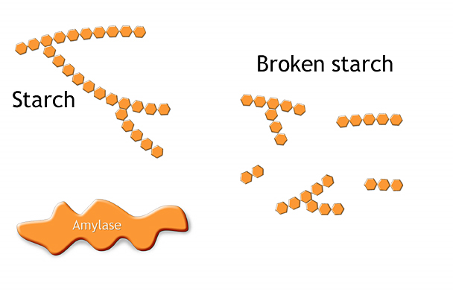
7. Once food is acidified in the stomach, amylase continues to digest starch.
a. True
b. False
8. The digestive enzyme ________ begins the breakdown of proteins in the stomach.
9. Pepsin is inactivated in the duodenum.
a. True
b. False
10. Pancreatic __________ is responsible for the majority of fat digestion.
11. Most water and salt are absorbed in the colon.
a. True
b. False
12. The active transport of sodium is necessary for water absorption in the small intestine.
a. True
b. False
13. The final digestion of carbohydrates is accomplished with ______ ______ enzymes.
14. Which of the following is NOT a brush border enzyme?
a. Amylase
b. Sucrase
c. Dextrinase
d. Glucoamylase
15. Place the following labels on the figure below:
Luminal side
Facilitated diffusion transporter
Basolateral side
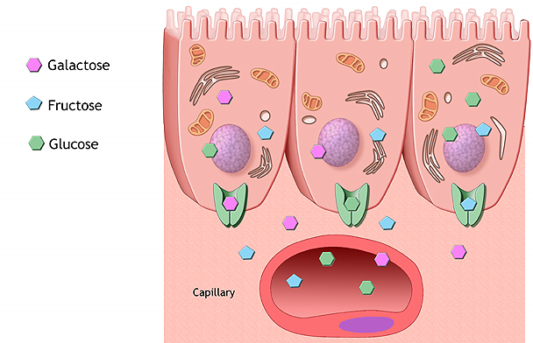

16. List the three major pancreatic proteases.
- __________
- __________
- __________
17. Only single amino acids are absorbed in the small intestine.
- True
- False
18. List the two main brush border proteases
- __________
- __________
19. List the two mechanisms that help to increase the surface area of lipids for subsequent digestion with pancreatic lipase.
- __________
- __________
20. Bile salts surround monoglycerides and free fatty acids to form tiny droplets called ________.
21. Triglycerides combine with lipoproteins inside the intestinal epithelial cells to form __________.
22. Chylomicrons exit the intestinal epithelial cells and then enter the ________ lymphatic capillaries.
23. The colon epithelium produces substantial amounts of digestive enzymes.
- True
- False
24. Colic bacteria produce substantial quantities of ________ ___ as a by product of their metabolism.
25. List the three main substances that are absorbed in the large intestine.
- ________
- ________
- ________

