The Digestive System: Secretion

- Of the approximately 9.0 L of fluids contained in the digestive tract daily, only __________ L are eliminated with the feces.
- Of the approximately 800 g of food ingested during a typical day, only about ____ g are eliminated as undigested food in the feces.
- Label the parotid, submandibular, and sublingual salivary glands in the figure below:
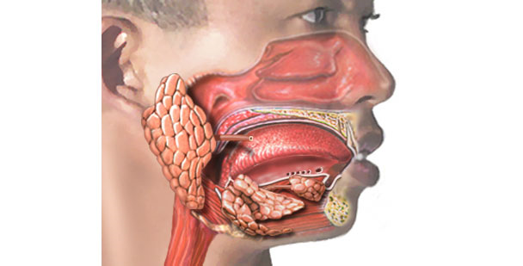
- List the four major functions of saliva.
  - ___________
  - ___________
  - ___________
  - ___________
- Parasympathetic innervation to the salivary glands is transmitted by cranial nerves number_______ and _______.
- Both the sympathetic and parasympathetic divisions of the ANS stimulate the salivary glands.
  - True
  - False
- ________ division innervation stimulates watery, enzyme-rich saliva secretion, whereas ________ division innervation stimulates, a mucus-rich, more viscous saliva secretion.
- Label the figure below with the terms parasympathetic and sympathetic.

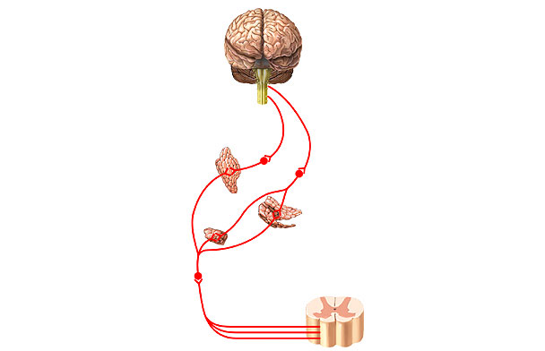
9. The esophagus secretes digestive enzymes.
a. True
b. False
10. The four main components of gastric juice are:
a. _________
b. _________
c. _________
d. _________
11. Gastrin is released from the ______ region of the stomach.
12. Place the following labels on the figure below:
parietal cell: HCl + IF
chief cell: pepsinogen
paracrine cell: histamine
mucus neck cells
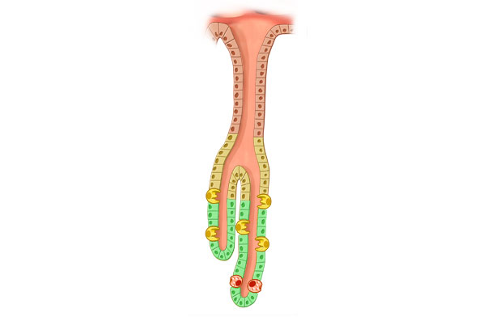

13. Gastrin producing G-cells are found in the gastric glands located in the ________ region of the stomach.
14. List the only two substances that are absorbed across the stomach’s mucosal epithelium
a. _________
b. _________
15. HCl in the stomach produces a pH of between ________ in the luminal fluid.
16. Which of the following is a function of HCl in the stomach?
a. Activates pepsinogen
b. Breaks down cell walls
c. Kills most bacteria
d. Denatures proteins in food
e. All of the above are functions of HCl
17. Without _______ _______, vitamin B₁₂, necessary for normal RBC development, can not be absorbed by the intestine.
18. List the two secretions that stimulate HCl release from parietal cells.
a. __________
b. __________
19. During the cephalic phase _________ neural reflexes stimulate an increased production of gastric juice.
20. Lipids in the intestine cause the release of the hormone_______, while acid in the intestine causes the release of ______.
21. Match the following pairs of terms:
CCK & secretin - bicarbonate pancreatic juice & enzyme-rich pancreatic juice
22. List the three major proteases (inactive forms) secreted by the exocrine pancreas
a. ________
b. ________
c. ________
23. Intestinal ________ converts (activates) trypsinogen into trypsin.
24. The pancreatic hormone _______ regulates the absorptive state, while ______ regulates the post-absorptive state.
25. List the four organic components of bile:
a. ________
b. ________
c. ________
d. ________
26. Intestinal digestive enzymes that are embedded in the epithelial microvilli membranes are called ________ ________ enzymes.
27. The intestinal hormone _____ causes contraction of the gall bladder and release of bile into the duodenum.
28. _______ _______protects the wall of the large intestine from mechanical damage and from damage by bacterial acid.

