The Digestive System: Motility
- The process by which food is received into the GI tract via the mouth is called _____________________.
- The esophagus is digestive in function.
a. True
b. False
- Swallowing has both voluntary and involuntary components
  - True
  - False
- The function of the epiglottis is to prevent a bolus from entering the _____.
- The first wave of contraction of the esophageal muscles is called ______ ______.
- If a food bolus does not make it all the way to the stomach, _________ peristalsis forces the bolus the remainder of the way.
- Peristaltic contractions of the stomach occur about _____ times per minute when food makes it into the body & fundus.
- The frequency of peristaltic contractions is regulated by ________ cells.
- Gastric emptying would be slowed by which of the following:
  - Fats in the duodenum
  - Acids in the duodenum
  - Hypertonic solutions in the duodenum
  - Distention of the duodenum
  - All of the above
- ______ regulate gastric juice secretion during the cephalic phase.
- *Now would be a great time to fill in the interactive table on page 7 of the Motility topic.
- The cephalic phase of digestion is regulated by short reflexes
  - True
  - False.
- The _______ nerve carries electrical signals from the brain to the stomach.
- The hormone ______ regulates gastric secretion during the gastric phase of digestion.
- Gastric motility ________ as the stomach begins to receive food.
- The hormone ______ released by the duodenum cause gastric motility to decrease when fats are present in the duodenum.
- The hormone _______ causes the gall bladder to contract and release bile into the small intestine.
- The ________ reflex describes the communication between the intestine and the stomach.
- Sympathetic nervous system stimulation ________ digestive system activity.
- The motility process illustrated below is _________.
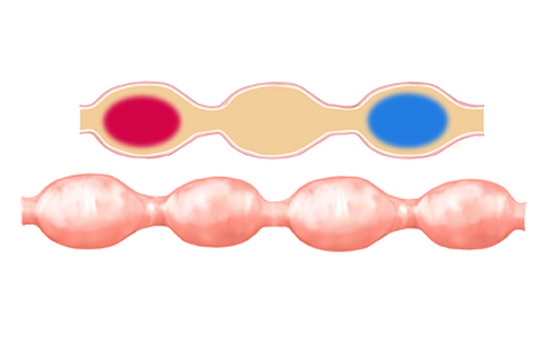

- Segmentation moves chyme in only one direction.
  - True
  - False
- The frequency of segmentation contractions is greatest in the _____.
- _____ reflexes stimulate the ileum to increase activity when food is in the stomach.
- The hormone _________ causes the ileocecal sphincter to relax during the gastric phase.
- During the inter-digestive period, _______ _______ _______ occur about once every 90 minutes to move undigested materials toward the terminal ileum.
- Migrating motility complexes are controlled by the central nervous system
  - True
  - False
- List the two major functions of the large intestine.
  - _______________________
  - _______________________
- Pockets formed by the contractions of the transverse and descending colon musculature are called ___________.
- Sustained, intense propulsive peristaltic contractions of the large intestine are called __________ ___________.
- Which of the following is under voluntary control?
  - Internal anal sphincter
  - External anal sphincter
- Only about _______ ml of the 500 ml of chyme that entered the colon is voided as feces.
- Place the following labels on the large intestine figure below:
Cecum, ascending colon, transverse colon, descending colon, sigmoid colon, rectum, haustra, appendix
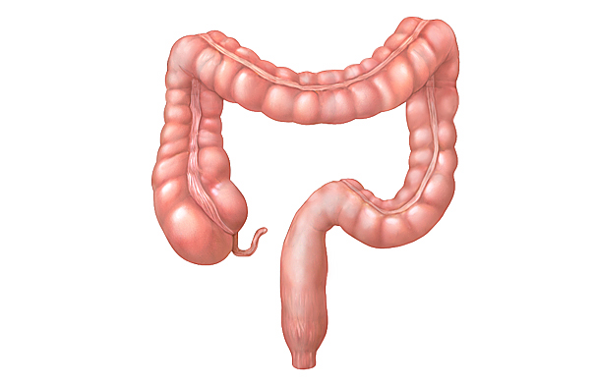
- The ________ reflex stimulates mass movements of the colon.
- List three emotions that may produce constipation
  - ______
  - ______
  - ______.
- The vomiting reflex is coordinated in the _________.
- Which of the following is not typically a stimulus for the vomiting reflex?
  - Noxious chemicals
  - Abnormal vestibular stimulation
  - Sudden injury to the testes
  - Sleep

